# Data Engineering II Final Project

Project Summary

As a part of the curriculum of the Master 2 (M2) course entitled “Data Engineering II”, the students will complete a team project work. Each team is composed of 2 members, and the members will take care of dividing the tasks equally between them. The purpose of this project is to combine all the skills collected throughout the entire course, and to provide a solid example of real-life application development in a DevOps environment.

The following sections provide necessary information about the description of the application to be created.

For any further detail, please contact the instructor: **Khodor Hammoud**

## 1. User Stories

* The application is a Twitter search application, where the user inputs a search string, and the application returns the top 20 tweets which are similar to the search string.
* The text language used must be English
* The application should have a web interface with an input form and a submit button, where users can input their search string, and hit submit, then a list of the 20 results is displayed.
* Every functional part of the application must be tested for proper functionality.
* The application must be able to handle 1000 requests per minute.
* The application must be easily deployable.
* The application must be properly monitored after deployment, we want to be able to quickly find any issue that might cause performance problems or down time.

2. Application Overview

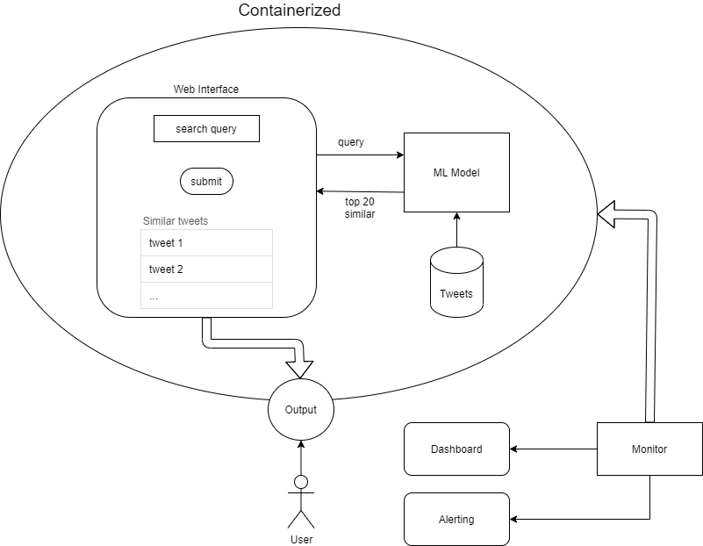

3. Technical Description

**3.1 The Similarity Search**

The students will use word embedding models to facilitate similarity searches. I.e: the word embeddings of the search string are compared with those of the available tweets (using which ever distance algorithm the students choose, like eucledian distance for example) and the top 20 similar tweets are chosen.

The students are free to choose whichever word embedding model they choose, like Fasttext, Doc2Vec, Word2Vec…

**note: a reminder to handle all the cleaning and pre-processing of the text.

**3.2 The Web Interface**

The students are free to choose whichever technology they know/like to create the web insterface. The end result should be a running application which the end user can access through a web browser, and start using immediately.

**3.3 The Application Package**

The final format of the application ready for distribution should be a Docker Image, which administrators can simply run Containers from. Students should provide a description file with their submitted application in which whey describe how to run their image (like providing on which port does the application run by default…).

4. Technical Requirements

The students are to use the following technologies and steps throughout their implementation:

**4.1 Task Management**

Each team is to use a project management tool of their choice (Trello, Asana, Jira…) to coordinate the tasks between the team members. Divide the user stories into tasks, list these tasks on the project manager, and track the progress of each task as it progresses. Each team is required to present their project management history during their presentation.

**4.2 Source Code Management**

Each team is required to create a github repository containing their project, and use it as their version control. Each new task should have its own branch on the github repository. At every task completion (from the project manager), the associated team member should merge their task’s branch to the master branch. The github repository should contain all your files, including the docker file and any meta data files (like the python requirements.txt if it exists).

Students must use the CD version control branching scheme, where the version control repository will contain a master branch, a develop branch, a feature branch (for every added feaure) and a release branch (for every version release).

**4.3 Testing**

Each team should provide unit integration, and stress tests to their final application.

* Unit tests are in the form of testing the functionality of each function of your program (when applicable).
* Integration testing will be testing the entire system integrated.
* Stress testing will be writing a user simulation to prove that your application can handle 1000 requests per minute.

**4.4 Automation**

The students are to use Jenkins for automating the building, testing, deployment and release (if applicable) of the application. At the end, each team is expected to have a Jenkins pipeline constructed which connects to the different github branches, and applies appropriate respective actions:

* build and run unit tests on feature branches.
* stress test and push to release on the develop branch
* wait for user acceptance on the release branch before pushing to master
* deploy on merging with master

**note: as it might not be possible to have multiple development environments (develop, staging, live), relasing/deploying the code can be substituted with simple print statements.

**4.5 Containarization**

The final application deliverable should be a Docker image, that contains the pre-trained model as well as the application web interface. The twitter dataset should also be bundled with the application. Running a container off the delivered image should allow users to view a web interface on their browser and be able to immediately start running queries.

**4.6 Monitoring**

The students are to use Prometheus to monitor:

* Hardware metrics: like CPU usage, memory usage, and disk space usage.
* Software metrics: integrate different software metrics inside your application to monitor information like response time, user requests count, exceptions,

Integrate Counters, Gauges, Histograms and Summaries as you see fit.

Add rules and alerts where you see fit, here are some examples:

* Alert before running out of memory
* Alert when cpu usage is very high
* Alert when your code raises an exception
* Alert when your system is down for more than a specific period of time
* …

Use Grafana as the monitoring dashboard.

One nice example to have is to visualize the different monitored metrics during the stress test.